The International Symposium on Frontier in Chemical Engineering:

The 17th Annual Conference of the Global Chinese Chemical Engineering Scholars (GACCE-2025)

**Queenstown and Auckland** • **New Zealand** • **Aug. 13-18,2025**

**Registration Guideline for Internal Participants**

If you DON’T have a Chinese cell phone number, please use your email address for New User Registration via the channel for "International Participants".

1. Click <https://gacce2025.scimeeting.cn/>
2. Enter, select the conference registration button, and enter the conference information registration.

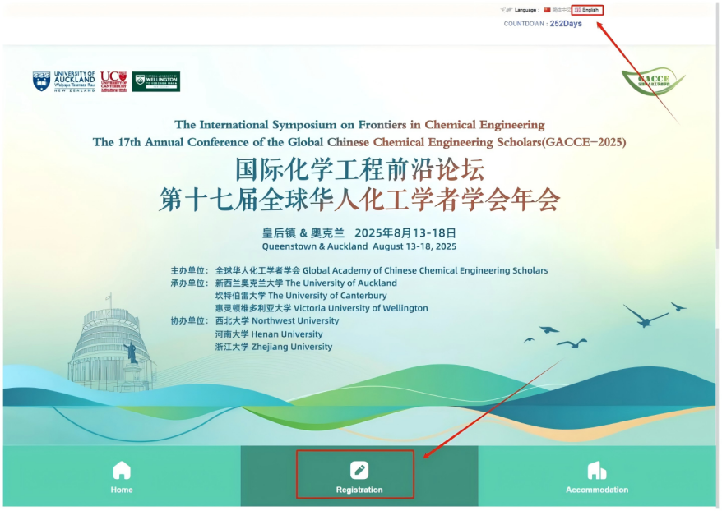

1. On the account password login or email login interface, select "New User Registration" or "Login" to enter the information filling interface.

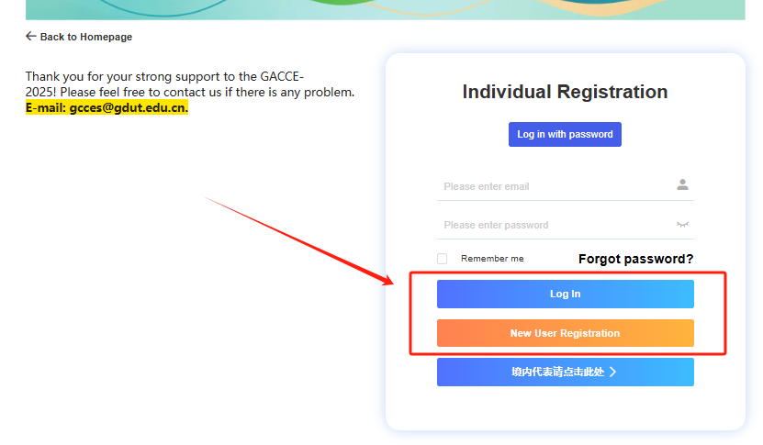

1. Follow the prompts on the page, fill in personal information, and click "Submit Now" after completing the information.

Note: must select oversea location rather than China as your “Country/Region” when filling the registration otherwise the website will automatically redirect to Chinese version which requires a working Chinese cell phone number。

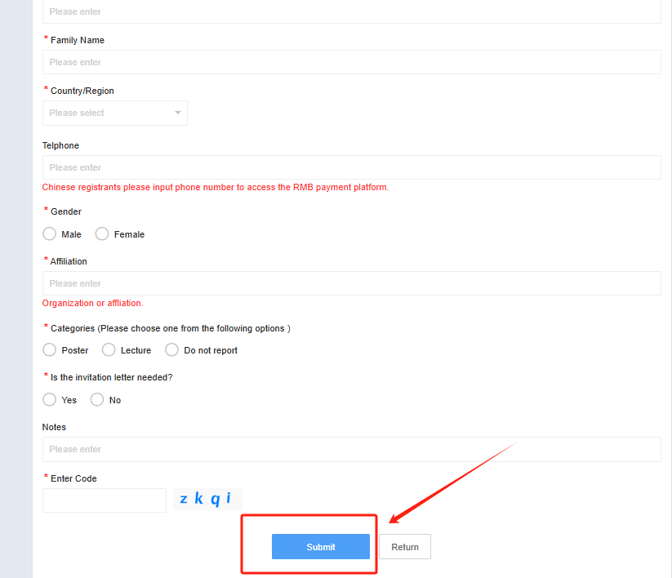

Note: If you select “Lecture” on the venue located in “Queenstown”, you will be supposed to participate the whole conferences in both venues (Queenstown and Auckland) and will be charged for the corresponding registration fee.

1. After submitting the information, all registration information will be searchable under the "Personal Information" section.

